IS ALL VITAMIN C THE SAME?
Many times a year people will say to me that vitamin c is vitamin c so it does not matter what kind you purchase. Well, we are going to answer that question by checking the quality of the product.
This is what the FDA has to say: Dietary supplements are not subject to pre-market approval for safety and effectiveness by the FDA and some have been found to contain undeclared drug ingredients. Of products found to be adulterated more than once, the majority were reported to contain new drug ingredients in subsequent warnings, indicating that adulterated dietary supplements continue to be an issue even after FDA action.
The FDA also checked 300 other herbal products and or supplements and found that one of the brands did not contain the ingredient listed on the label. The capsules were filled with dirt.!! And there are companies that are using the wrong part of the plant so it will not be effective, weight-loss ingredients in herbs, Cipro in herbal formulas, etc.
So is vitamin c still vitamin c no matter who you buy from? This not only applies to vitamin c but to every herbal or supplement product. Some years ago I contacted several well known companies and asked for their quality control and only one company had quality control. One man laughed at me and said "Quality control, we don't have quality control".
And this is what Nature's Sunshine has to say about quality control:
1. RAW MATERIAL SOURCING
Our on-site vendor inspections guarantee that only the cleanest, purest material becomes part of our products. We cut no corners and regularly reject raw material that does not meet our exacting standards.
2. FORMULATE FOR EFFICACY
With over 47 years of experience and proven techniques, NSP combines the wisdom of expert formulators with natural health legend to create unique, effective products with proven results.
3. QUALITY IN-HOUSE MANUFACTURING
NSP invests millions of dollars annually in Quality Assurance, including state-of-the art equipment, testing methods and qualified personnel. Because we control the entire process, we KNOW what's in our products and what is not.
4. FINISHED PRODUCT TESTING
We work meticulously to ensure that the precise amounts of the right parts of the right plant species are included in our formulas. This testing includes HPLC and infra-red analysis of botanical blends and analytical assays for vitamin and mineral label claims.
As part of our uncompromising commitment to quality, we use advanced analytical equipment to conduct over 600 quality and purity tests on our products. Some of these tests include: heavy metals, radiation, dirt and other impurities, yeast and mold pathogens, pesticides and herbicides.
With that being said, how do the products you are using compare with NSP? It is not a matter of cost but rather a matter of safety to you and your family.

For more information on quality control, contact me:
920-772-4135
maryellen@mynsp.com
http://www.mynsp.com/maryellen

September special at Roadway To Health - 25% off the retail price of any in stock product

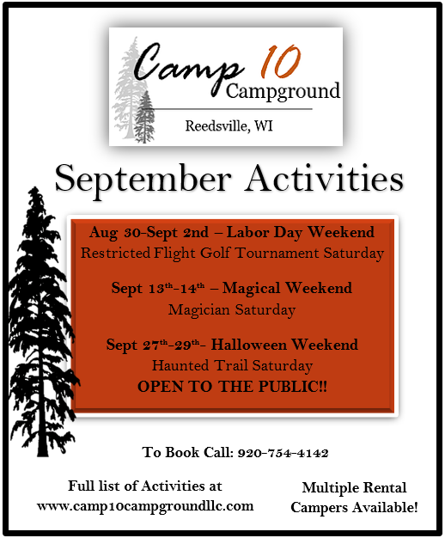

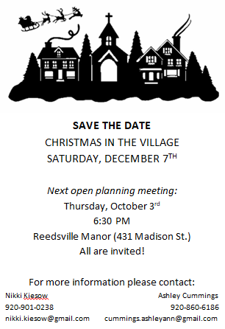

CORRAL PANELS FOR SALE AT SUNRISE HORSE FARM
We have 32 - 10 foot panels for sale. They were $69.99 per panel at Tractor Supply two years ago and are now $79.99 per panel and we will sell them for $60.00 a panel. As the panels were only used for a year for our blind horse and have been stored inside they are in excellent condition.
TACK FOR SALE
Western saddles:
Buffalo saddle - $250
Texas Maker - "Abetta" 16" gullet, 15" seat - $150
English saddles:
15" close contact - $250
Crosby - 17.5" seat - close contact - "Sovereign" - $300
In addition to the saddles there are saddle pads, saddle stands, decorative headstalls, halters, bridles, blankets and sheets, and miscellaneous items for sale,

Do you have time to volunteer? This is what Angie had to say about volunteering at Sunrise Horse Farm: I love to volunteer at Sunrise Horse Farm for the main reason that no matter what kind of day I'm having, whether good, bad, or worse, I can go there guaranteeing it will fill my heart with joy! It could be seeing a kiddo smile as they bond with a horse, or a soft nuzzle against my cheek from Smokey or Spencer or just having a conversation with the lady that makes it all possible, Mary Ellen, who never has an unkind word to say! I have made so many friends young and old and it is truly time I look forward to spending at every week and has kept me coming back for the last 10 years!

Yes Angie has been a part of Sunrise for 10 years and has done numerous behind the scene activities that few people know about such as baking a cake for one of the students that never had a birthday cake and surprising him with a party while he was here or at Christmas time she had cookies all baked and the students decorated them to take home to their families, and when we have family gatherings to make cards for the residents at the Manor and others she brings a kit with pens and decorations for the cards. And that is just a few examples of her kindness...she has definitely made life pleasant for the children and teens that come to Sunrise. Plus the horses love her, too.

Contact us about being a volunteer or to set up a time to check out the tack and panels.

SUNRISE HORSE FARM, INC
17226 Limekiln Road
Reedsville, Wisconsin 54230
www.sunrisehorsefarm.org
920.772.4135

